Purpose

The purpose of this experiment is to determine: (1) the percentage of copper in a copper-clad penny and (2) the thickness of the copper layer on the copper-clad penny. These analyses will employ spectrophotometric techniques, a required skill tested on the College Board AP Chemistry exam.

Penny Background

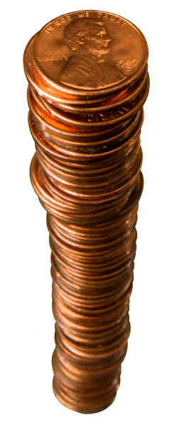 Pennies minted in the United States since 1982 no longer contain pure copper metal. This change was due to the fact that the cost of the copper metal required to produce a penny was higher than the face value of the penny. In fact, pennies minted after 1982 consist of a copper “coating” on a core that is comprised of an alloy containing both zinc and copper (the core is mostly zinc, however). This is not the first time that zinc has been used in pennies. Perhaps you have seen the “steel-gray” pennies minted in 1943 which were a result of World War II. Copper at the time was being conserved for the war effort and the pennies minted in that year consisted of a zinc “coating” on a steel core. Moreover, due to the high cost of silver, all other coins minted in the United States no longer contain this precious metal. The silver appearance of nickels, dimes, and quarters is due to nickel metal which is used along with copper in these coins. For example, if you look at the edge of a dime or a quarter, you will clearly see a layer of copper

Introduction

**Complex ions** are ions formed by the bonding of a metal atom or ion to two or more **ligands** by coordinate covalent bonds. A **ligand** is a negative ion or neutral molecule attached to the central metal ion in a complex ion. Many of these species are highly colored due to their ability to absorb light in the visible region of the electromagnetic spectrum. In this experiment, you will first dissolve a copper-clad penny in a concentrated aqueous solution of nitric acid, HNO3. In aqueous solution, most of the first-row transition metals form **octahedral complex ions** with water as their ligands as shown below in Equations 1 and 2:

Cu(s) + 4 HNO3(aq) + 4 H2O(l) 🡪 Cu(H2O)62+(aq) + 2 NO2(g) + 2 NO3-(aq) (1)

Zn(s) + 4 HNO3(aq) + 4 H2O(l) 🡪 Zn(H2O)62+(aq) + 2 NO2(g) + 2 NO3-(aq) (2)

Once the penny has been dissolved, you will then convert the equated copper and zinc complex ions to their **tetraamine** complex ions (i.e., by replacing the H2O ligands with ammonia, NH3, ligands) as shown below in Equations 3 and 4:

Cu(H2O)62+(*aq*) + 4 NH3(*aq*) 🡪Cu(NH3)42+(*aq*) + 6 H2O(*l*) (3)

Zn(H2O)62+(*aq*) + 4 NH3(*aq*) 🡪Zn(NH3)42+(*aq*) + 6 H2O(*l*) (4)

You can detect the presence of the Cu(NH3)42+ ion by its characteristic deep-blue color. Not only can you see the blue color, but you can measure its intensity with a spectrophotometer. By using the spectrophotometer, you will be able to make measurements that will make it possible for you to determine the percentage of copper in a penny.

**I. INTRODUCTION TO UV AND VISIBLE SPECTROSCOPY1**

When white light passes through or is reflected by a colored substance, a characteristic portion of the mixed wavelengths is absorbed. The remaining light will then assume the complementary color to the wavelength(s) absorbed. Thus, absorption of 420-430 nm light renders a substance yellow, and absorption of 500-520 nm light makes it red. Green is unique in that it can be created by absorption close to 400 nm as well as absorption near 800 nm.

When sample molecules are exposed to light having an energy that matches a possible electronic transition within the molecule, some of the light energy will be absorbed as the electron is promoted to a higher energy orbital. An optical spectrometer records the wavelengths at which absorption occurs, together with the degree of absorption at each wavelength. The resulting spectrum is presented as a graph of absorbance (A) versus wavelength. **Absorbance** usually ranges from 0 (no absorption) to 2 (99% absorption), and is precisely defined in context with spectrometer operation.

Because the absorbance of a sample will be proportional to the number of absorbing molecules in the spectrometer light beam (e.g. their molar concentration in the sample tube), it is necessary to correct the absorbance value for this and other operational factors if the spectra of different compounds are to be compared in a meaningful way. The corrected absorption value is called "molar absorptivity", and is particularly useful when comparing the spectra of different compounds and determining the relative strength of light absorbing functions (chromophores).

**Molar absorptivity** (ε) is defined as:

**Molar Absorptivity, ε = *A/(b*c)**

*A*= absorbance, **c** = sample concentration in moles/L & **b** = length of light path through the sample in cm.) or sometimes shown as l (length of light pathway/diameter of cuvette)

**DEPENDENCE ON CONCENTRATION:**

UV/Vis spectroscopy is frequently used to determine unknown concentrations. Rearranging the formula for Beer’s law gives:

**A = εbc**

A broad range of **standard** solutions of **known** concentration are prepared and the absorbance is determined. A graph of **A vs. [conc]** is made and the equation from the best fit line is then used to determine the unknown concentration. **Typically wavelength is chosen to provide the maximum absorbance** (λmax)

Absorbance is a logarithmic scale and difficult to read on analog spectrometer (as shown on the line diagram below). In this case, the linear scale of % transmittance is read. Unfortunately, %T is not linearly related to concentration, so the following formulas must be used to convert from %T to absorbance readings.

***A = log10 (100 / %T) OR A = 2 - log10 %T***





**II. USING A SPEC 20**



**1. Power and Zero knob** – The spectrophotometer needs to warm up 15 minutes prior to use. This knob is also used to set the spec at 0% transmittance when there is no cuvette in the holder.

**2. Wavelength knob** – This will be set at the assigned wavelength at the beginning of the experiment an remain until the end of the lab. **NOTE:** Some of our Spec 20’s have a filter lever on the bottom left hand side that must be move to the left or right side according to the wavelength.

**3. Cuvette holder** – Gently place the cuvette in the holder making sure to line up the line on the cuvette with the raised line in the holder (see picture).

**4. Full Scale knob** – a **blank** will be placed in a cuvette and cuvette holder. Use this knob to set the %T to 100. Zeroing and blanking must be done throughout the lab to make sure the spectrophotometer calibration is stable.

**5. Transmittance scale** (You will read this scale)

**6. Absorbance scale** (You will use %T to calculate the absorbance)

**IV. Experiment**

Split your lab partners into different roles for efficiency: Penny reaction, Standard preparation, Spec 20 operation.

**ROLE ONE: Copper Extraction from the Penny**

**1.** Determine the mass of a POST-1982 penny.

**2.** Bring your penny to the hood or outside in the natural “hood”. You will place your penny in 8 M HNO3. **GOGGLES PEOPLE!** This reaction generates NO2 which is highly toxic. **DO NOT BREATHE THE FUMES**.

**3.** Cover your beaker with a watch glass and leave in the hood until it completely dissolves. Call your group over to gather qualitative data on the chemical reaction. You do not need to monitor the entire reaction. While this is occurring, go on to the next part, but keep checking your beaker for evidence of reaction completion.

**4.** IN THE FUME HOOD, transfer the solution in which you dissolved your penny to a 100 mL flask. Use a small portion of distilled water to rinse down the watch glass and the sides of the beaker and transfer the washes to the same 100 mL flask. Add distilled water to the mark, cap the flask and shake to mix thoroughly.

**5.** Using a graduated pipet, transfer 2.50 mL of the penny solution to a 10 mL graduated cylinder.

**6. In the fume hood:** You will you add concentrated ammonia drop by drop while shaking until any precipitate that forms disappears.

**7.** Dilute with the 1.2 M NH3 as before until you have 10 mL of solution.

**8.** Cap your flask and mix thoroughly, save this penny sample to analyze.

**9.** Zero and 100% the spectrophotometer using the 1.2 M NH3 as the blank

**10.** Rinse a cuvette (or small test tube) with **small** portions of the solution in volumetric flask and discard the rinses**.** Then, add the solution from volumetric flask to the cuvette until it is about **3/4 full** and insert it into the spectrophotometer.

**11.** Record the % transmittance. Repeat steps 5-10, record as trial 2.

**ROLE TWO: Standard Solution preparation for the Cu(NH3)42+ Calibration Curve**

Each group will make **ONE** of the following standard solutions. When they are complete, bring them to your spec 20 location so they can be shared with the class. **The original copper (II) nitrate standard is in the burets in the back of the lab.**

1. Add the designated amount of Cu(NO3)2 •3H2O from the chart to a 50 mL flask. You will be delivering from a buret: (a) read the initial volume on the buret (b) add to that volume the mL of Cu(NO3)2**•**3H2O you want to deliver (c) open the stopcock and carefully release solution to the final mark.
2. Dilute with the 1.2 M NH3 until the bottom of the meniscus is on the line. Use a Beral pipet (disposable) for the dilution so you will not overshoot the mark.
3. Cap your flask and mix thoroughly.
4. Bring your standard to the center table.
5. Label 7 test tubes and obtain about 5 mL of each of the standard solutions. DO NOT USE CUVETTES FOR THIS PART. The cuvettes have a characteristic circle and line on them. They must be treated with the utmost of care.

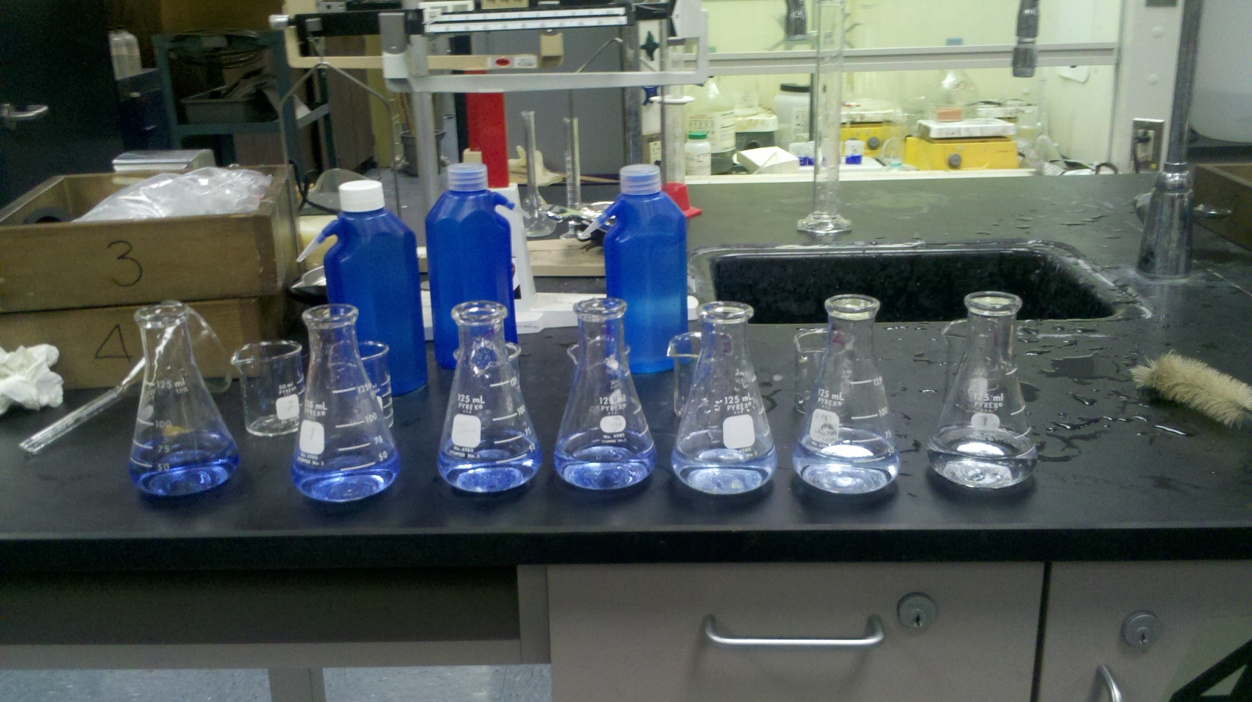

**ROLE THREE:** Spec 20 calibration

**1.** Turn on the Spec 20

**2.** Obtain two cuvettes. Treat these cuvettes very carefully. Scratches and stains will ruin them. One will be used to calibrate the spectrophotometer the other for the standard solutions. Only touch the tops of the cuvettes. Fingerprints will interfere with the absorbance. Use Kimwipes to clean and dry your cuvette.

**3.** You will be using the maximum absorbance of the Cu+2 ion. Your spectrophotometer should be set to 580 nm.

**4.** Zero and 100% the spectrophotometer using the 1.2 M ammonia solution as the blank

**5.** Rinse the cuvette with a **small** portion of solution to be measured. Fill the cuvette approximately **¾ full** and determine the %T for each of the solutions, using a Kimwipe to clean the outside of the cuvette before reading. DO NOT measure A from the spectrophotometer, it will be much more accurate to calculate A from %T.

**6.** Measure the %T of the your penny solution.

**ANALYSIS: CONSTRUCTION OF A CALIBRATION CURVE FOR Cu(NH3)42+**

1. **Making the graph:** First you will construct a calibration curve that relates the measured absorbance, A, to known concentrations of the Cu(NH3)42+ ion using the **Beer-Lambert Law**.

**2.** **Plot your unknown:** You will then use the calibration curve to determine the concentration of Cu(NH3)42+ in the solution prepared from your penny.

3. Calculate ∈ for all trials and average your results. Using the average and the equation below, calculate the C of your unknown penny solution. You should have two values, one from the graph and one from this calculation. Compare.

As you have seen previously, concentration and absorbance are related according to the Beer-Lambert Law (Equation 5):

**A = *εl*C**  (5)

where **A** is the absorbance of the species,

***ε*** is the molar absorptivity (a constant that indicates how well the species absorbs light of a particular wavelength, in units of M-1 cm-1).

***l*** is the path length that the light must travel through the solution (1.00 cm for the cuvet),

**C** is the concentration(in mol/L).

4. Using the concentrations you have just calculated in above and taking into account the various dilutions performed, calculate the mass in grams of copper initially present in your penny. Calculate the **percentage** of copper in your penny by dividing the mass of copper in your penny by the total mass of your penny and multiplying this result by 100.

5. In the copper-clad penny, the core contains 0.8% copper and 99.2% zinc by mass. Because we want to calculate the thickness of the copper layer on the core, you will need to subtract the mass of copper that is in the core from the total mass of copper that you determined spectrophotometrically. This will give the mass of copper that is in the copper shell. For example, the total mass of zinc in the penny is equal to the total mass of the penny minus the total mass of the copper in the penny:

Total mass of Zn = Total mass of penny - Total mass of Cu (7)

Now, all of the zinc that is present in the penny is in the core. Since 99.2% of the total mass of the core is due to zinc, you can use your previously calculated value for the total mass of Zn and calculate the mass of the core:

Total mass of Zn = 0.992 (Total mass of core) (8)

Once you have calculated the total mass of the core, the mass of copper present in the core can be calculated by subtracting the total mass of zinc from the total mass of the core:

Mass of Cu in core = Total mass of core - Total mass of Zn (9)

The mass of copper in the coating is then simply the total mass of copper minus the mass of copper in the core:

Mass of Cu in coating = Total mass of Cu - Mass of Cu in core (10)

6. Using your data, calculate the **volume** (in cm3) of copper present in the copper coating for your penny using the known density of copper. You may use the average values that you calculated for your penny.

7. Using the volume of copper that you calculated for the copper coating, calculate the **thickness** (in cm) of the copper coating on your penny using the dimensions you recorded earlier. This can be computed by dividing the volume of the copper coating (in cm3) by the total surface area of the penny (in cm2). Recall that we are assuming the penny to be perfectly cylindrical. Thus, the surface area of a cylinder is given by the formula shown below in Equation 11:

π(d/2)2 + π(d/2)2 + π(d)(t) (11)

where **d** is the diameter of the penny (in cm),

**t** is the thickness of the penny (in cm),

π = 3.14159 (a constant)

DISCUSSION/ERROR ANALYSIS

Include a discussion of the following in your lab report:

1. Using the following graphs, explain why the wavelength was set at 580 nm.

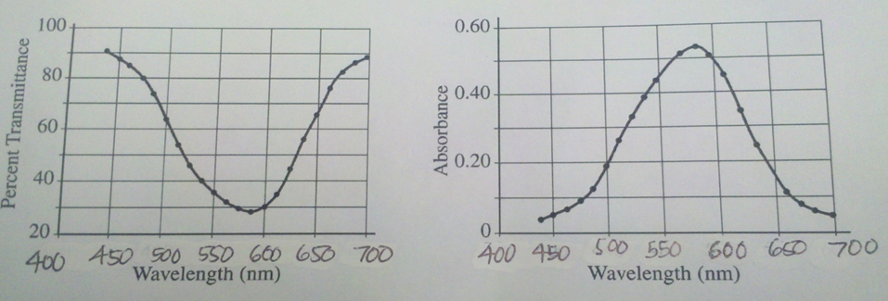

2. Why can’t you use spectrophotometric determination to identify the concentration of the zinc ion? Or the unknown concentration of sodium chloride solution?

3. Why do we read percent transmittance instead of absorbance from the spec 20? Also, why do we need absorbance instead of just using %T? Refer to the graphs on page 3.

4. Compare the information about various pennies from other lab groups. Describe any similarities and/or differences in the total percentage of copper and in the thickness of the copper layer for pennies:

1. Minted in different years,

2. Minted in different cities,

3. With different initial appearances.

5. When you carefully added ammonia to your solutions containing copper, a light-blue precipitate formed initially that eventually disappeared as more ammonia was added. What do you think this precipitate was? Write the formula and explain your reasoning.

DATA

|  |  |
| --- | --- |
| weight of penny | g |
| thickness of penny | mm |
| diameter of penny | mm |
| year minted |  |
| produced by mint in |  |
| appearance of penny |  |

|  |  |  |  |
| --- | --- | --- | --- |
| DATA TABLE | | | |
| Cu(NO3)2 • 3H2O molar mass = 241.60 g/mol  0.939g in 250mL (you will need to calculate this molarity) | | | |
|  |  | %T | A | | [ ] |
| 1 | 2 mL |  |  | |  |
| 2 | 2.5 mL |  |  | |  |
| 3 | 3.5 mL |  |  | |  |
| 4 | 4.5 mL |  |  | |  |
| 5 | 5.5 mL |  |  | |  |
| 6 | 7 mL |  |  | |  |
| 7 | 9 mL |  |  | |  |
| Your penny sample | |  |  | |  |

Concentration of penny sample from graph __________

Concentration from calculations (show work)________

Compare/contrast. Which one is more accurate? Why?

Show work for : 3-5 and equations 7-11